Virtual Reality Revolution

Virtual reality is a technology that allow users to interact with real objects being simulated using a computer. Actually, Virtual memory is the environment / objects that exist only in the imagination that is capable of generating three-dimensional atmosphere that makes the user as if physically involved.  
Example: flight simulation.  
Pilots can use a virtual reality system to perform flight simulation before the actual flight.

Virtual Reality is the appearance of three-dimensional images that raised by the computer, which is visible with the help of some devices. The most important feature is to use a device designed for a specific purpose, this technology is able to make people who play in the virtual world to believe that they are in the real world.

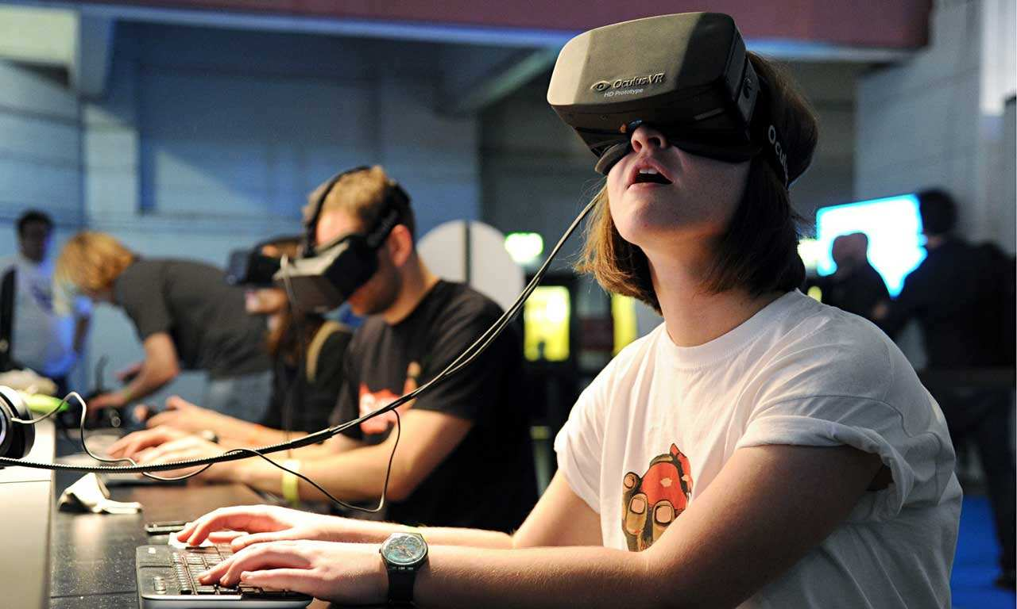 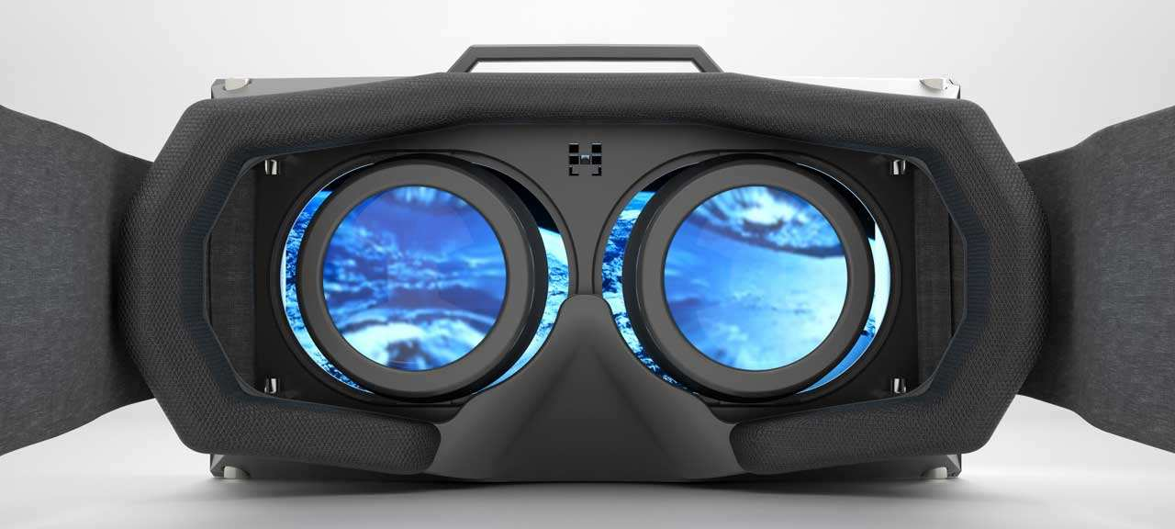

One example of virtual reality applications used at this time is in the military field. Virtual reality used to simulate war games, simulation exercises parachuting. etc. Where the use of this technology can save more cost and time compared to the conventional way.

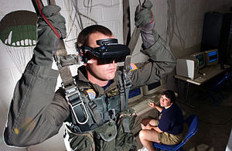

A soldier AL USA spring using a parachute VR trainer.

Advantages and Disadvantages

Advantages :

  Could facilitate the work of the various aspects of computers in designing a building such as buildings, hotels and the design house plans.  
     Can do some exercises as complicated as flying a plane.

Deficiency :  
  
     Increase unemployment because fewer people are needed in designing the project.  
     Manufacturing is still very limited.  
     Manufacturing costs tend to be expensive.

<https://niiasaba.wordpress.com/2010/06/10/virtual-reality/>

<http://temukanpengertian.blogspot.com/2013/08/pengertian-virtual-reality.html>

<http://www.duniaku.net/2014/06/02/tren-video-game-virtual-reality-nikmati-game-melalui-mata-yang-baru/>

<https://yanceqalam.wordpress.com/2013/10/13/virtual-reality-vr-peg-tek-internet-dan-new-media/>

<http://thetoyzareboyz.blogspot.com/2010/02/virtual-reality.html>

<https://www.academia.edu/3891464/Kelebihan_dan_Kekurangan_Virtual_Reality_Kelebihan_Kekurangan>